Lab 2-1 Configuring an Implicit Fact Column
Goals | To identify whether a query is using an implicit fact column or not, define the implicit fact column, and then re-execute the query to identify whether or not the results differ.
Scenario | ABC Company is tracking product return information. There have been some discrepancies between some queries when a metric is not specified. You have been asked to look into this.
Time | 15 – 20 minutes
Environment | 
Instructions:
- Disable the existing implicit fact column in the SupplierSales presentation layer. This column was enabled to ensure consistent querying in the labs, but you are investigating what happens when it is disabled.
  - If necessary, open the ServArchAdv.rpd in online mode as Administrator with a blank password.
  - Right-click the SupplierSales Presentation Catalog in the Presentation layer and select Properties.
  - Click Yes to check out the objects.
  - Click Clear in the Implicit Fact Column area of the Presentation Catalog dialog box.
  - Click OK.
  - Select File > Check In Changes.
  - Click Yes to check consistency.
  - Click OK to confirm that the repository is consistent.
  - Select File > Save to save the repository.
- Execute a query in Analytics to identify whether Analytics is executing the query with an implicit fact column. Since you just disabled the implicit fact column, you expect that the query will not.
  - Start Siebel Analytics Web and log in as Administrator.
    - Select Start > Programs > Siebel Analytics > Siebel Analytics Web.
    - Enter Administrator as the User ID.
    - Leave the password blank.
    - Click Log In.
  - Click the Answers link.
  - Click the SupplierSales Subject Area.
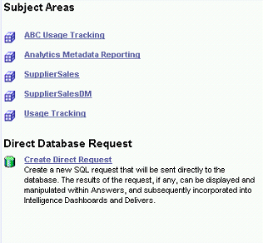
  - Select Customers.Customer and Periods.Day.
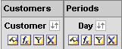
  - Filter on the Barbecue Lodge Inc customer.
    - Click the Filter icon on the Customer column.
    - In the Create/Edit Filter dialog box enter criteria is equal to / is in Barbecue Lodge Inc Your screen should appear as follows:
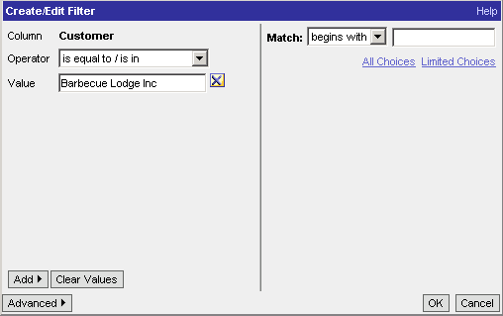
    - Click OK.
  - Click the Results tab.
  - How many records are returned?
  - View the log for the query you just executed.
    - Click Admin.
    - Click Manage Sessions.
    - Click View Log for the query you just ran.
  - Were any measures listed in the query?
  - Was an implicit fact defined?
  - How do you know whether or not the correct number of records was returned by the query?
  - Close the Session Monitor window.
  - Click Finished.
  - Click Close Window.
  - Click Log Out to log out of Analytics Web.
  - Close the browser to clear the browser cache.
- Define a metric as an implicit fact column to specify the join path when a presentation layer subject area is queried.
  - In the Siebel Analytics Administration Tool, right-click the SupplierSales folder in the Presentation layer and select Properties.
  - Click Yes to check out objects.
  - In the Presentation Catalog dialog box, click Set in the Implicit Fact Column section.
  - In the Browse dialog box, select SalesFacts.Dollars as the implicit fact column for the SupplierSales Subject Area.
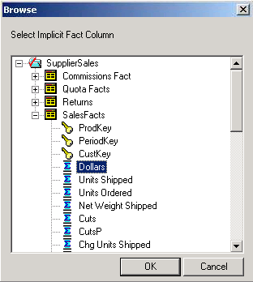
  - Click OK. Your implicit fact column is now set:
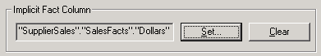
  - Click OK.
  - Check in your changes, checking consistency.
  - Save the repository.
- Re-execute the same query in Analytics to identify whether Analytics is executing the query with an implicit fact column or not to specify the join path for the dimensions.
  - Log in to Siebel Analytics Web as Administrator with no password.
  - Click Answers.
  - Click the SupplierSales Subject Area.
  - Click Reload Server Metadata.
  - Select Customers.Customer and Periods.Day.
  - Filter on the Barbecue Lodge Inc customer.
  - Click the Results tab.
  - Scroll to the bottom of the screen and click the All Pages button.
  - How many records are returned?
  - View the log for the query you just executed.
    - Click Admin.
    - Click Manage Sessions.
    - Click the View Log for the query you just ran.
  - Were any measures listed in the query?
  - Was an implicit fact defined?
  - Close the Session Monitor window.
  - Click Finished.
  - Click Close Window.
  - Log out of Analytics Web.
Solutions 2-1 Configuring an Implicit Fact Column
Answers
2.g. How many records are returned?
1
2.i. Were any measures listed in the query?
No.
2.j. Was an implicit fact defined?
No.
2.k. How do you know whether or not the correct number of records was returned by the query?
We do not know whether or not the query result is correct because the join path does not appear to be defined in the query as depicted in the query log.
3.i. How many records are returned?
217
3.k. Were any measures listed in the query?
No.
3.l. Was an implicit fact defined?
Yes, the primary query to return records went through the Sales Facts table.

